Lab 11
Mutability and Immutability
Lab Task:
- Apply concept of mutability and immutability for the task promoted and failed students. The roll number, subject code, and subject name would have to be entered at time of object creation and with getter method these variables should be printed.
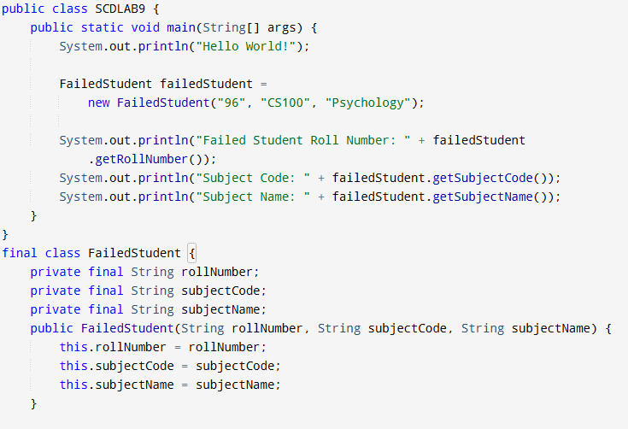
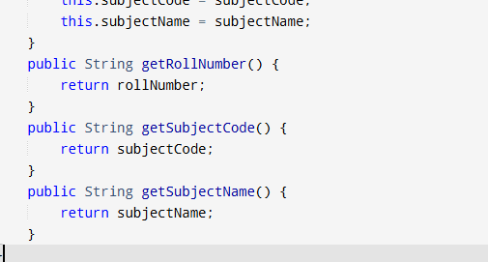
Output:
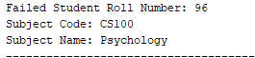

Code:

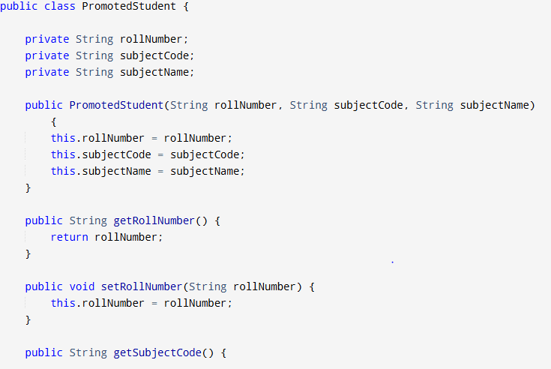

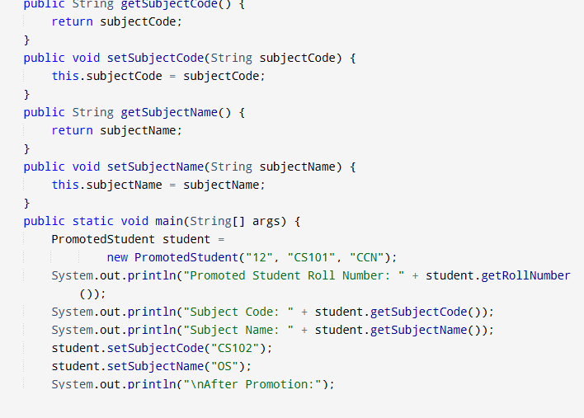
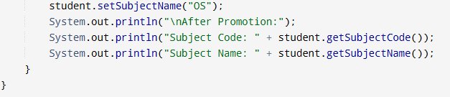

Output:
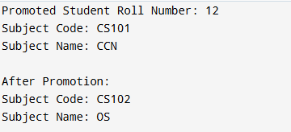

- Write a program that will calculate the below 4 formulas. Decide what to make mutable and what to make immutable and perform task operations. Formulas are:
Circumference of circle: C = 2 π r
Area of circle: A = π r²
Volume of sphere: V = 4/3 π r³
Surface area of sphere: A = 4 π r²
Code:
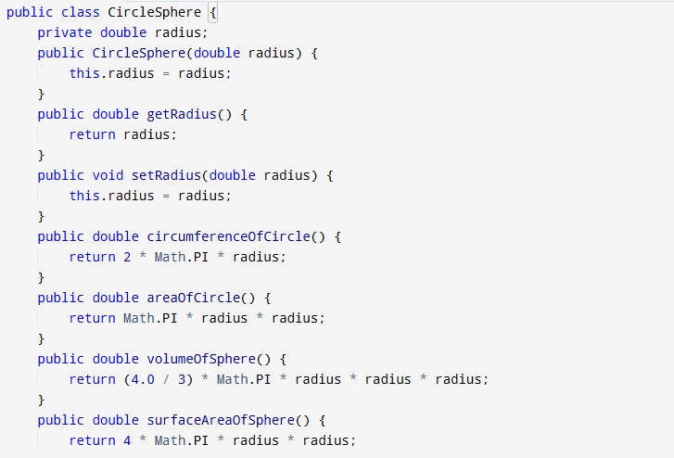
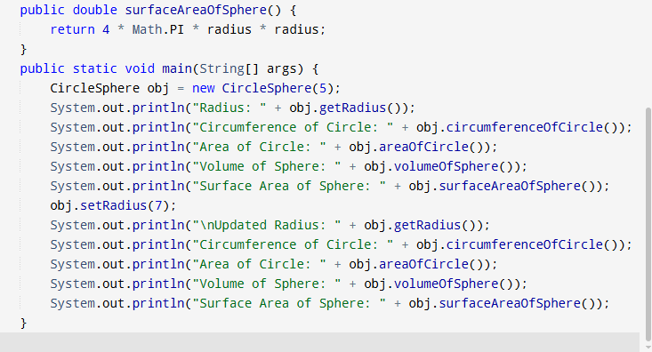
Output:
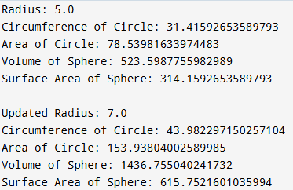

GITHUB SCREENSHOT:
